Superior University, Lahore
Artificial Intelligence (Lab)
Lab 4 Report
Informed Search: Heuristics & A*
Subject: Artificial Intelligence Lab

Name: Ayesha Fayyaz

Roll No: SU92-BSAIM-F25-117

Program: BS Artificial Intelligence, Superior University of Lahore

Submitted to: Sir Rasik

Section: AI-3B

1. Problem Statement
A campus navigation system knows the actual travel time spent so far and also has an estimate of the remaining travel time. It must reach a destination building while expanding fewer irrelevant states than an uninformed search. This lab applies the A* algorithm to a small weighted graph of campus buildings S, A, B, C and G, where S is the start and G is the destination. Edge weights are travel-time units.
Objectives: (1) compute g(n), h(n) and f(n) = g(n) + h(n); (2) implement A* with a priority queue; (3) compare A* with Uniform-Cost Search (UCS) using measured expansion counts; (4) investigate what happens when the heuristic overestimates.

1.1 Graph and Heuristic
Node | Outgoing edges (cost) | h(n) given | True remaining cost
S | S->A (1), S->B (4) | 5 | 6
A | A->C (2) | 4 | 5
B | B->G (5) | 4 | 5
C | C->G (3) | 2 | 3
G | - | 0 | 0

There are exactly two complete routes: S -> A -> C -> G with cost 1 + 2 + 3 = 6 (optimal), and S -> B -> G with cost 4 + 5 = 9.

2. Assumptions
- The graph is directed and edge weights are travel-time units, so heuristic values are also time estimates in the same units.
- The supplied h values are abstract time estimates, not measured campus distances (raw metres cannot be added to travel time).
- Priority queue entries are (f, g, node, path). Ties on f are broken by the smaller g, then by node name; successors are examined in the order listed in the graph.
- A node counts as expanded only when its successors are examined. Popping the goal is logged but is not counted as an expansion.
- Stale queue entries (entries whose g is worse than the best known g for that node) are ignored.

3. Implementation Choices
The program is written in Python using only the standard library module heapq. The graph is a dictionary of adjacency lists and the heuristic is a dictionary of node -> estimate. A* keeps a best-g dictionary so that a cheaper path found later replaces an older one (the older queue entry becomes stale and is skipped). UCS is obtained from the same function by setting every h value to zero, which keeps the graph, start, goal and tie-breaking identical so that the comparison is a controlled one. The function returns the path, the cost, the list of processed nodes and the list of expanded nodes, so counts are measured from the trace and never guessed.
Source file:
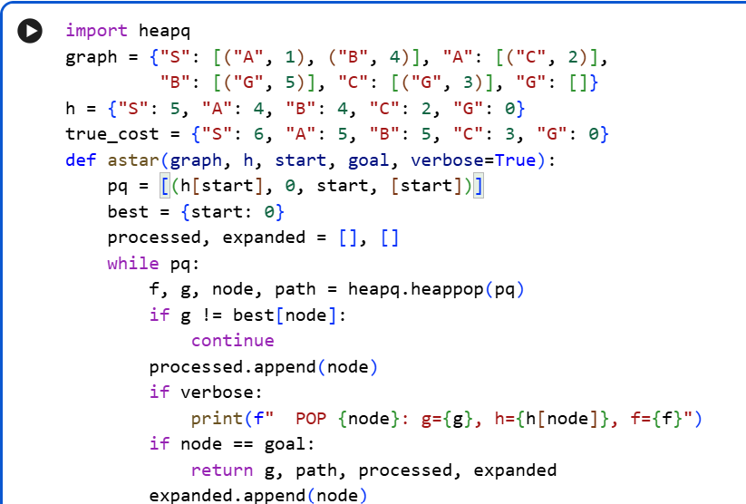
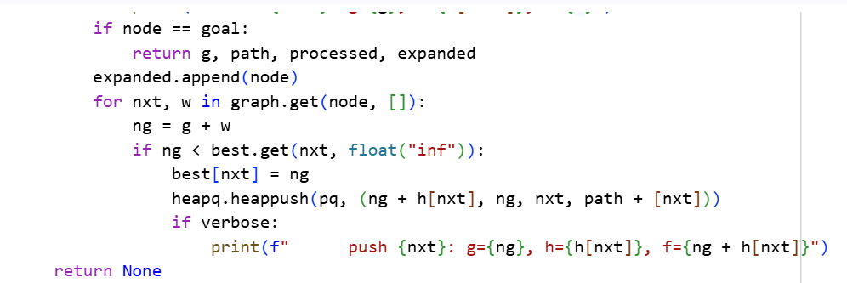

4. Heuristic Audit

4.1 Admissibility
A heuristic is admissible if it never overestimates the true remaining cost. True remaining costs: S = 6 (via A, C), A = 2 + 3 = 5, B = 5, C = 3, G = 0.
Node | h(n) | True cost | h <= true? | Result
S | 5 | 6 | 5 <= 6 | Pass
A | 4 | 5 | 4 <= 5 | Pass
B | 4 | 5 | 4 <= 5 | Pass
C | 2 | 3 | 2 <= 3 | Pass
G | 0 | 0 | 0 <= 0 | Pass

The heuristic is admissible on this small instance, established by explicit verification of every node.

4.2 Consistency
For every directed edge u -> v we check h(u) <= cost(u,v) + h(v).
Edge | Check | Values | Result
S -> A | h(S) <= 1 + h(A) | 5 <= 5 | Pass
S -> B | h(S) <= 4 + h(B) | 5 <= 8 | Pass
A -> C | h(A) <= 2 + h(C) | 4 <= 4 | Pass
B -> G | h(B) <= 5 + h(G) | 4 <= 5 | Pass
C -> G | h(C) <= 3 + h(G) | 2 <= 3 | Pass

All edges pass, so the supplied heuristic is consistent. Consistency implies that f(n) never decreases along a path, and that the first time a node is selected its g value is already optimal.

5. Task 1: Manual g, h, f Calculation (First Three Expansions)
Formula: f(n) = g(n) + h(n). Start: S with g = 0.

Expansion 1: select S
- g(S) = 0, h(S) = 5, so f(S) = 0 + 5 = 5. The frontier initially contains only S, so S is selected.
- Successors of S: A: g = 0 + 1 = 1, h = 4, f = 1 + 4 = 5. B: g = 0 + 4 = 4, h = 4, f = 4 + 4 = 8.
- Frontier after expansion: A (g=1, h=4, f=5), B (g=4, h=4, f=8).

Expansion 2: select A
- A has the smallest f (5 < 8), so A is selected: g(A) = 1, h(A) = 4, f(A) = 1 + 4 = 5.
- Successor of A: C: g = 1 + 2 = 3, h = 2, f = 3 + 2 = 5.
- Frontier after expansion: C (g=3, h=2, f=5), B (g=4, h=4, f=8).

Expansion 3: select C
- C has the smallest f (5 < 8), so C is selected: g(C) = 3, h(C) = 2, f(C) = 3 + 2 = 5.
- Successor of C: G: g = 3 + 3 = 6, h = 0, f = 6 + 0 = 6.
- Frontier after expansion: G (g=6, h=0, f=6), B (g=4, h=4, f=8).

Step | Node | g | h | f | Calc | Remaining frontier after expansion
1 | S | 0 | 5 | 5 | 0+5 | A (1+4=5), B (4+4=8)
2 | A | 1 | 4 | 5 | 1+4 | C (3+2=5), B (4+4=8)
3 | C | 3 | 2 | 5 | 3+2 | G (6+0=6), B (4+4=8)

Why the next node is G: after expanding C the frontier is {G with f = 6, B with f = 8}. Since 6 < 8, A* selects G next. G is the goal, so the search stops with path S -> A -> C -> G and cost 6. Node B was never expanded.

6. Task 2: A* versus UCS
Both runs use the same graph, start S, goal G, tie-breaking and counting convention. UCS is the same code with all h values set to 0.

6.1 Captured output (A*)
POP S: g=0, h=5, f=5 push A (f=5), push B (f=8)
POP A: g=1, h=4, f=5 push C (f=5)
POP C: g=3, h=2, f=5 push G (f=6)
POP G: g=6, h=0, f=6 goal reached
Path: S -> A -> C -> G | cost 6
Processed: [S, A, C, G] | Expanded: [S, A, C] | Count = 3

6.2 Captured output (UCS, h = 0)
POP S: g=0, f=0 push A (f=1), push B (f=4)
POP A: g=1, f=1 push C (f=3)
POP C: g=3, f=3 push G (f=6)
POP B: g=4, f=4 (G via B would cost 9, not better than 6, no push)
POP G: g=6, f=6 goal reached
Path: S -> A -> C -> G | cost 6
Processed: [S, A, C, B, G] | Expanded: [S, A, C, B] | Count = 4

6.3 Comparison table
Measure | A* (supplied h) | UCS (h = 0) | Difference
Returned path | S-A-C-G | S-A-C-G | Same
Returned cost | 6 | 6 | Same
Independently summed cost | 1+2+3 = 6 | 1+2+3 = 6 | Same
Processed nodes | S, A, C, G (4) | S, A, C, B, G (5) | A* processes 1 fewer
Expanded nodes | S, A, C | S, A, C, B | -
Expansion count | 3 | 4 | A* expands 25% fewer
Stale entries ignored | 0 | 0 | None in either run

6.4 Interpretation
Both algorithms return the same optimal path with cost 6, as expected because the heuristic is admissible and consistent. The difference is efficiency: UCS orders the frontier only by g, so B (g = 4) is popped before G (g = 6) and gets expanded even though it leads nowhere useful. A* adds h, so B has f = 8 which is worse than G's f = 6, and B is never expanded. On this graph A* expanded 3 nodes against 4 for UCS. This claim is based on the measured trace of the same problem, not on path length. No stale entries occurred in either run, and the only counting difference is that the goal G is processed but excluded from the expansion count in both runs. Note that this is a very small graph, so the saving is small; the advantage normally grows with graph size.

7. Task 3: Overestimate Experiment
Only one heuristic value was changed: h(C) was changed from 2 to 10. The true remaining cost of C is 3, so 10 > 3 and the heuristic is deliberately no longer admissible. Everything else (graph, other h values, start, goal, tie-breaking) is unchanged.
Measure | Original h(C)=2 | Modified h(C)=10 | Changed?
h(C) vs true cost 3 | 2 <= 3 (admissible) | 10 > 3 (overestimate) | -
f(C) when generated | 3 + 2 = 5 | 3 + 10 = 13 | Yes
Returned path | S-A-C-G | S-B-G | Yes
Returned cost | 6 | 9 | Yes (worse)
Expanded nodes | S, A, C | S, A, B | Different set
Expansion count | 3 | 3 | No

7.1 Trace with h(C) = 10
POP S: g=0, h=5, f=5 push A (f=5), push B (f=8)
POP A: g=1, h=4, f=5 push C: g=3, h=10, f=13
POP B: g=4, h=4, f=8 push G: g=9, h=0, f=9
POP G: g=9, h=0, f=9 goal reached
Path: S -> B -> G | cost 9 (optimal is 6)

7.2 Explanation
With the overestimate, C looks very expensive (f = 13), so A* prefers B (f = 8) and then G through B (f = 9). Since G with f = 9 is smaller than C with f = 13, G is selected and the search ends with the cost-9 route. The truly better route through C (total 6) is never examined. A* guarantees optimality only when it never wrongly pushes a good node behind the goal; an overestimating heuristic breaks exactly this and removes the guarantee.
To show that a single unchanged run does not prove safety, I also tried h(B) = 10 (true cost of B is 5, so this also overestimates). In that run A* still returned S -> A -> C -> G with cost 6 and 3 expansions, because B's inflated f-value only pushed an already unwanted node further back. So some overestimates are harmless on a given graph, but one lucky run cannot prove a heuristic is safe; admissibility must be verified, not assumed.

8. Failure / Edge Case Analysis
Item | Description
Input | Same campus graph with h(C) changed from 2 to 10 (true remaining cost of C is 3).
Observed behaviour | A* returned S -> B -> G with cost 9 instead of the optimal S -> A -> C -> G with cost 6.
Likely cause | The heuristic overestimated at C, violating admissibility. f(C) = 13 made the good branch look worse than B (f = 8) and G via B (f = 9).
Proposed improvement | Before running A*, audit every heuristic value against known true remaining costs (computed by a backward UCS from G) and check h(u) <= cost(u,v) + h(v) on every edge. If a value fails, cap it with min(h(n), true cost) or use a safer heuristic such as h = 0 (UCS) for that node.

9. Limitations
- The graph has only five nodes, so the efficiency difference between A* and UCS (3 versus 4 expansions) is small and may not represent large maps.
- The heuristic values are abstract and supplied, not derived from real campus measurements.
- Admissibility was verified by hand for this instance only; the result does not prove the heuristic is safe on other graphs.
- The path is stored inside each queue entry, which uses extra memory on large graphs; storing parent pointers would be better.
- Only one overestimate run (plus one extra check) was tested, so the experiment is a counterexample, not a general proof.

10. Reflection
What did I learn today? I learned that A* ranks nodes by f(n) = g(n) + h(n), and that a good heuristic lets the search ignore branches such as B that UCS wastes time on. I also learned the difference between admissible and consistent heuristics.
How will I apply this in a real AI system? Pathfinding in maps, delivery routing and game AI all use A*. I would build the heuristic from real travel-time data in matching units and audit it before deployment.
What failed or surprised me? I was surprised that changing a single value, h(C) from 2 to 10, was enough to make A* return a worse route, while h(B) = 10 changed nothing.
What would I do differently next time? I would write an automatic admissibility checker first and test on a larger graph so the efficiency difference becomes more visible.

11. Responsible Practice
- Evidence-based claims: all efficiency statements are based on measured expansion counts from the same problem, graph and tie-breaking rule.
- Reproducibility: the code, inputs, README with run commands and captured output (output.txt) are provided in the GitHub repository.
- Sources: the guided A* code structure and the graph, heuristic and experiment definitions come from the CAI601400 Lab 4 manual (Section 4.2 to 4.7). The audit, UCS control and trace logging were added by me.
- Privacy and security: no credentials, personal data or virtual environments were uploaded to the repository.
- Real-world caution: a navigation system using wrong heuristics could send users on poor routes, so heuristics must be validated against real data before use.

12. Final Remarks
A* with the supplied admissible and consistent heuristic found the optimal route S -> A -> C -> G (cost 6) with 3 expansions, compared with 4 expansions for UCS. Deliberately setting h(C) = 10 broke admissibility and caused A* to return the cost-9 route, which shows that heuristic quality must be tested and not merely assumed

Appendix A: Complete Source Code
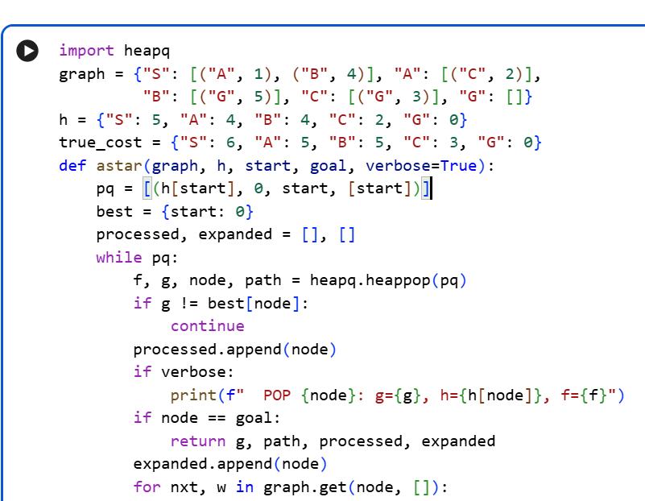 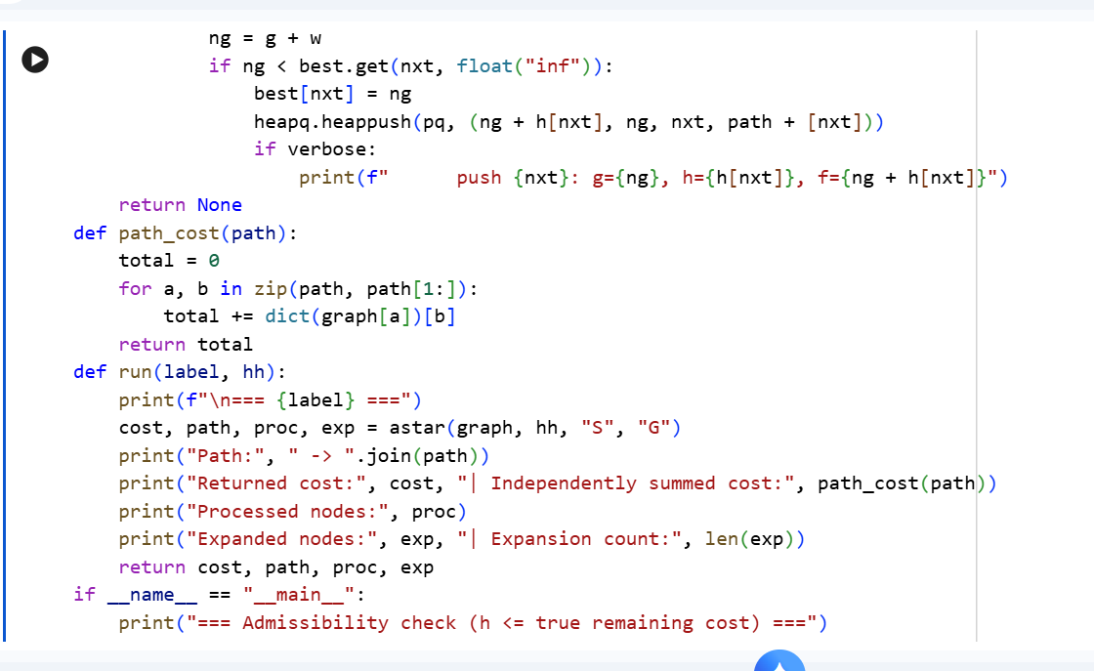 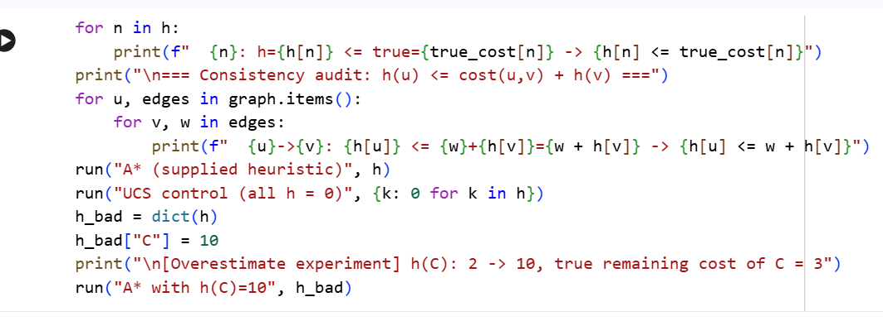 Appendix B: Complete Captured Output


